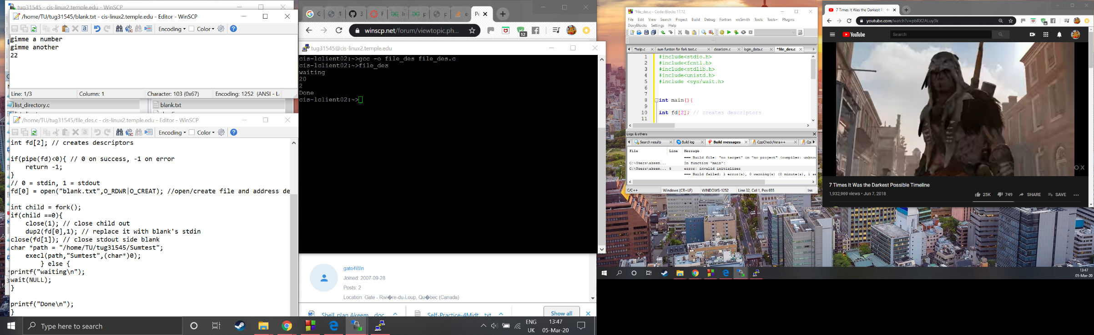

This screenshot shows a simple fork/piping practice

I open/create a file called blank.txt with read and write permission

I fork, replace the child’s stdout with the blanks stdin and call execl “Sumtest”

It doesn’t work perfect as sum prints to file but it still needs information from stdin which is not replaced.

This was just basic test as it would be simpler to simple redirect output vs piping but it has given me the basic principle of how this concept works and now I can work on how execlp will take command line arguments and further test playing around with file descriptors